**FUNDAMENTAL OF PROGRAMMING**

**HOME TASK 4**

**SUBMITTED BY ABDUL MANAN**

**QALAM ID : 462449**

**TASK 1**

#include <iostream>

using namespace std;

int main() {

int num = 0;

while (num<150){

if(num% 10==0){

num++;

continue;

}

else{

cout<< num <<endl;

}

num++;

}

return 0;

}

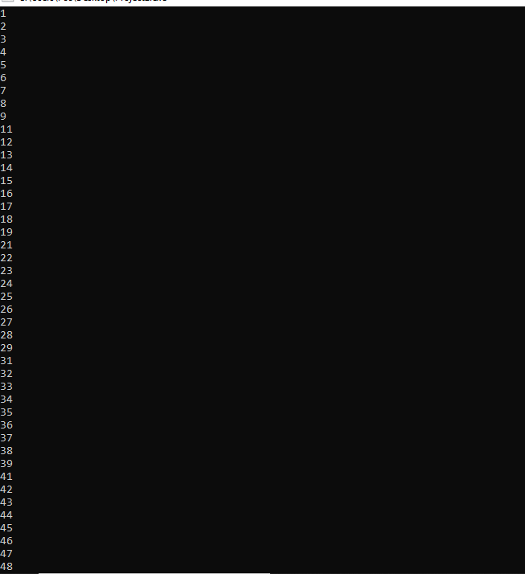

**TASK 2**

#include <iostream>

using namespace std;

int main(){

int num,num1,num2,sum;

cout<<"Please enter the number you want the sum of "<<endl;

cin>>num;

num1= num;

while(num>0){

num2=num%10;

sum+=num2;

num=num/10;

}

cout<< sum <<endl;

return 0 ;

}

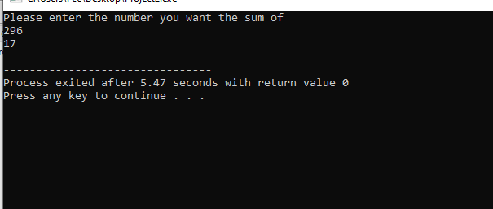

**TASK 3**

#include <iostream>

using namespace std;

int main(){

int i,num;

cout<<"please enter number "<<endl;

cin>>num;

for(i=2;i<num;i++){

if(num%i!=0){

cout<<"it is a prime number"<<endl;

break; }

else{

cout<<"it is not a prime number"<<endl;

break;

}

}

return 0;

}

